

**Hosting Options** :

For Django applications, we have a couple of options.



Virtual Private Servers are often less expensive but require more knowledge and effort to set up.

Other option is to use Platform as a service,

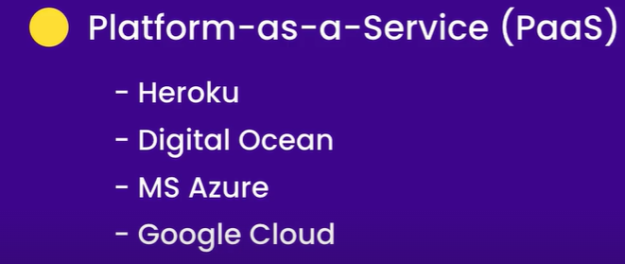

In this section, we will use Heroku.

**Adding Project to Git**:

Let’s talk about adding our project to source control and for that we will use GIT.

🡪 Install git:

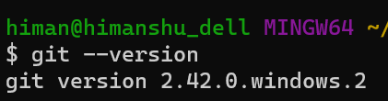

🡪 Open the project directory in git bash.

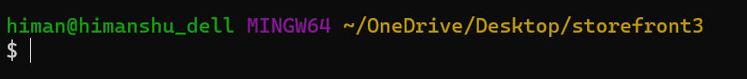

🡪 Initialize a git repository in this directory using,

git init



*A repository is like a database that holds snapshots of our project. So as we code and make changes, we take snapshots and store them in this repository, then later we can go back to these snapshots and view what changes we have made*.

🡪 Add all the modified files in a staging area using, so they are ready to be committed to git.

git add .

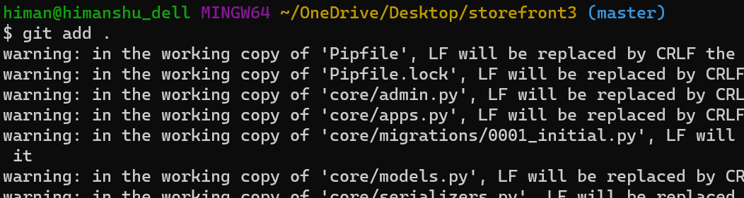

🡪 Create a snapshot of the project using commit and store it in the repository,

git commit -m “Initial commit”

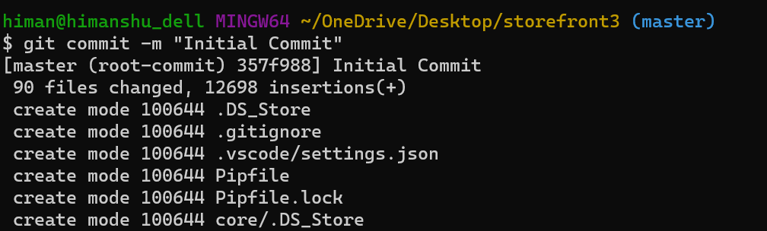

**Getting Started with Heroku**:

To deploy our application with Heroku, first we need to create an account.

Head over to heroku.com to sign up.

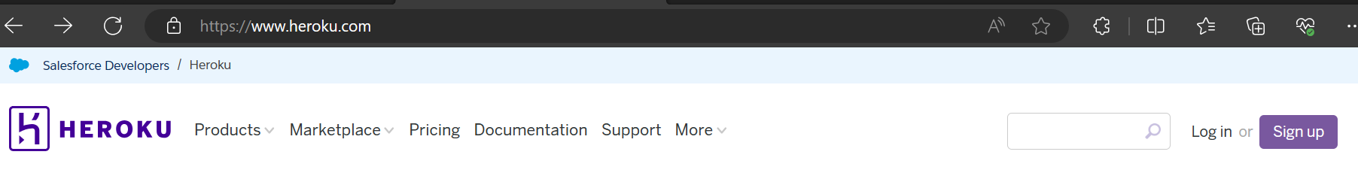

**Personal Side note**:

There is two factor authentication required to login to Heroku application dashboard.

So I suggest,

‘*Scan QR code using authenticator app*’ . I used Microsoft authenticator app from playstore.

After logging in,

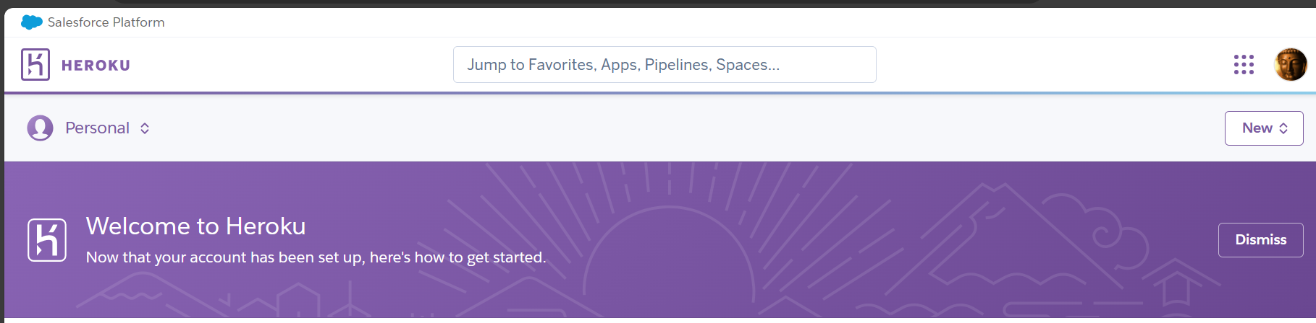

Next we need to download *Heroku CLI* or command line interface. We use it for managing and scaling our Heroku applications.

<https://devcenter.heroku.com/articles/heroku-cli#install-the-heroku-cli>

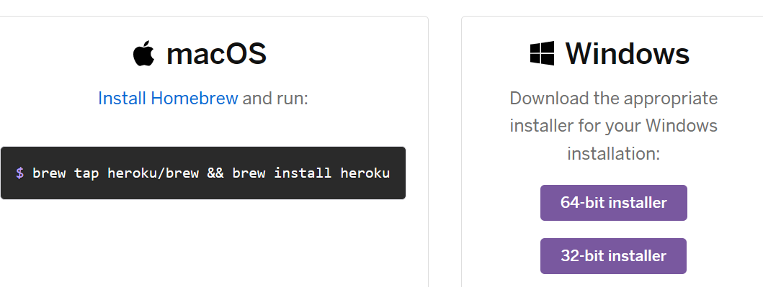

Installation steps:

🡪

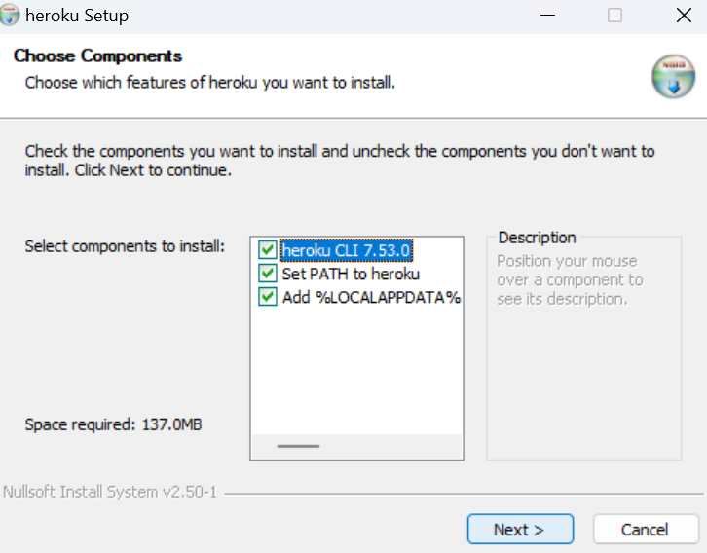

🡪

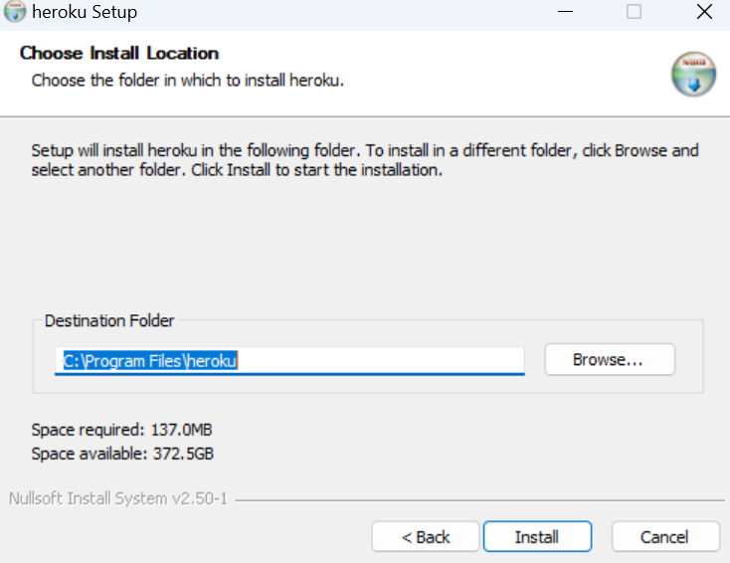

🡪

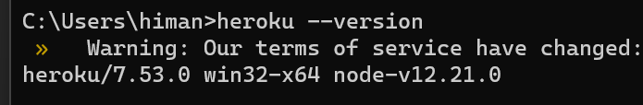

After installation is complete, lets login using,

heroku login

It says to press any key to open a browser,



It opens up our login page,

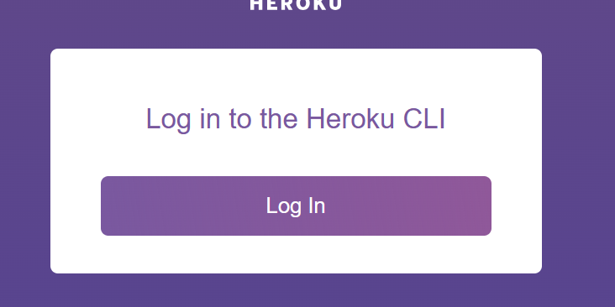

After pressing Log In,



We are logged in now,

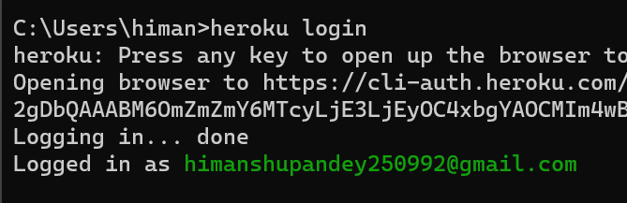

**Creating a Heroku app**:

Now we need to create a heroku app and for that we run,

heroku create lemoncommerce-prod

Here *lemoncommerce-prod* is a unique name we give to our app, with ‘*prod’* suggesting that it is a production environment (*with the same convention later can create another app with -stg means it’s a staging environment*).

Its asking to add payment information, in order to create an app.

